A PROJECT REPORT ON

E-COMMERCE (ONLINE BICYCLE) MANAGEMENT SYSTEM FOR

AISSCE 2020 EXAMINATION

As a part of the Informatics Practices Course (065)

***SUBMITTED BY:***

Name of the Student Hall ticket Number

1. Jatin K Rai
2. Deepak
3. Gagan

Under the guidance of

PGT in Informatics Practices



DEPARTMENT OF INFORMATICS PRACTICES

SRI CHAITANYA CBSE +2 College

Plot No:36/2, 4th Main, Reddy Compound, BOB Colony, JP Nagar, 7th Phase

**Bengaluru - 560078**

**CERTIFICATE**

This is to certify that the Project / Dissertation entitled **E-COMMERCE (ONLINE BICYCLE) MANAGEMENT SYSTEM is** a bonafide work done by **Mr. / Ms** of class

**XII** in partial fulfillment of CBSE’s AISSCE Examination 2019-20 and has been carried out under my direct supervision and guidance. This report or a similar report on the topic has not been submitted for any other examination and does not form a part of any other course undergone by the candidate.

Signature of Student Signature of Teacher/Guide

Name: Jatin K Rai

Roll No.: …………………… Designation: PGT in IP

Signature of Principal Place: JP Nagar

Date:……………..

# ACKNOWLEDGEMENT

I would like to thank the institution for giving the opportunity to encase and display our talent through this project.

I would like to thank my Informatics Practices teacherfor having the patience to guide me at every step in the project

I am also grateful to the **CBSE BOARD** for challenging and giving us this project in which we all were so engrossed.

I would also like to thank my parents and friends who helped me in getting the right information for this project.

.

TABLE OF CONTENTS

|  |  |  |
| --- | --- | --- |
| **S.No** | **Topic Name** | **Page No** |
| 1. | Abstract | 5 |
| 2. | System requirements | 6 |
| 3. | Database design | 7 |
| 4. | Coding | 13 |
| 5. | Output screens | 28 |
| 6. | Bibliography | 41 |

**ABSTRACT**

This is a project on the topic ‘e-Commerce (online bicycle) Management System’. In this project we have tried to design an interface for an efficient e-commerce (online bicycle) management.

By using this software, we can store all details of product (e.g. bicycle), customer (e.g. buyer) and sold and deliver product information in a database using python interface. Here, we can insert new product and customer details, updating existing product and customer details using product id or customer id, deleting existing product details or customer detail using product id or customer id, creating new database, creating new table(s). We can also search for specific record of a product or customer using product id or customer id.

# SYSTEM REQUIREMENTS

**Hardware Components**

1. VGA Monitor

2. Qwerty keyboard

1. 4GB RAM
2. 2.6 GHz Processor
3. Graphics card

**Software Components**

1. Windows 7 or 10
2. Python 3.8 with suitable modules
3. MySQL Command Client

# DATABASE DESIGN

Name of the database of this project: - **e-Commerce (online bicycle) Management System**

Tables created for this project: -

* 1. **Product Detail**
  2. **Customer Detail**
  3. **Sold-product Detail**

**Product Detail Table**

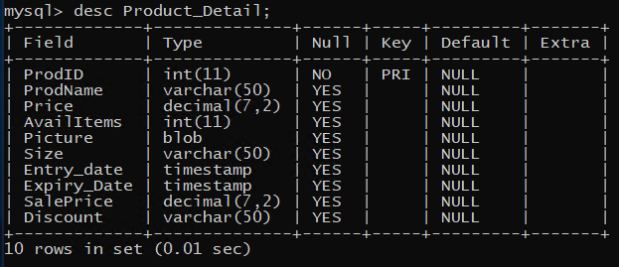

**Sample Data:-**

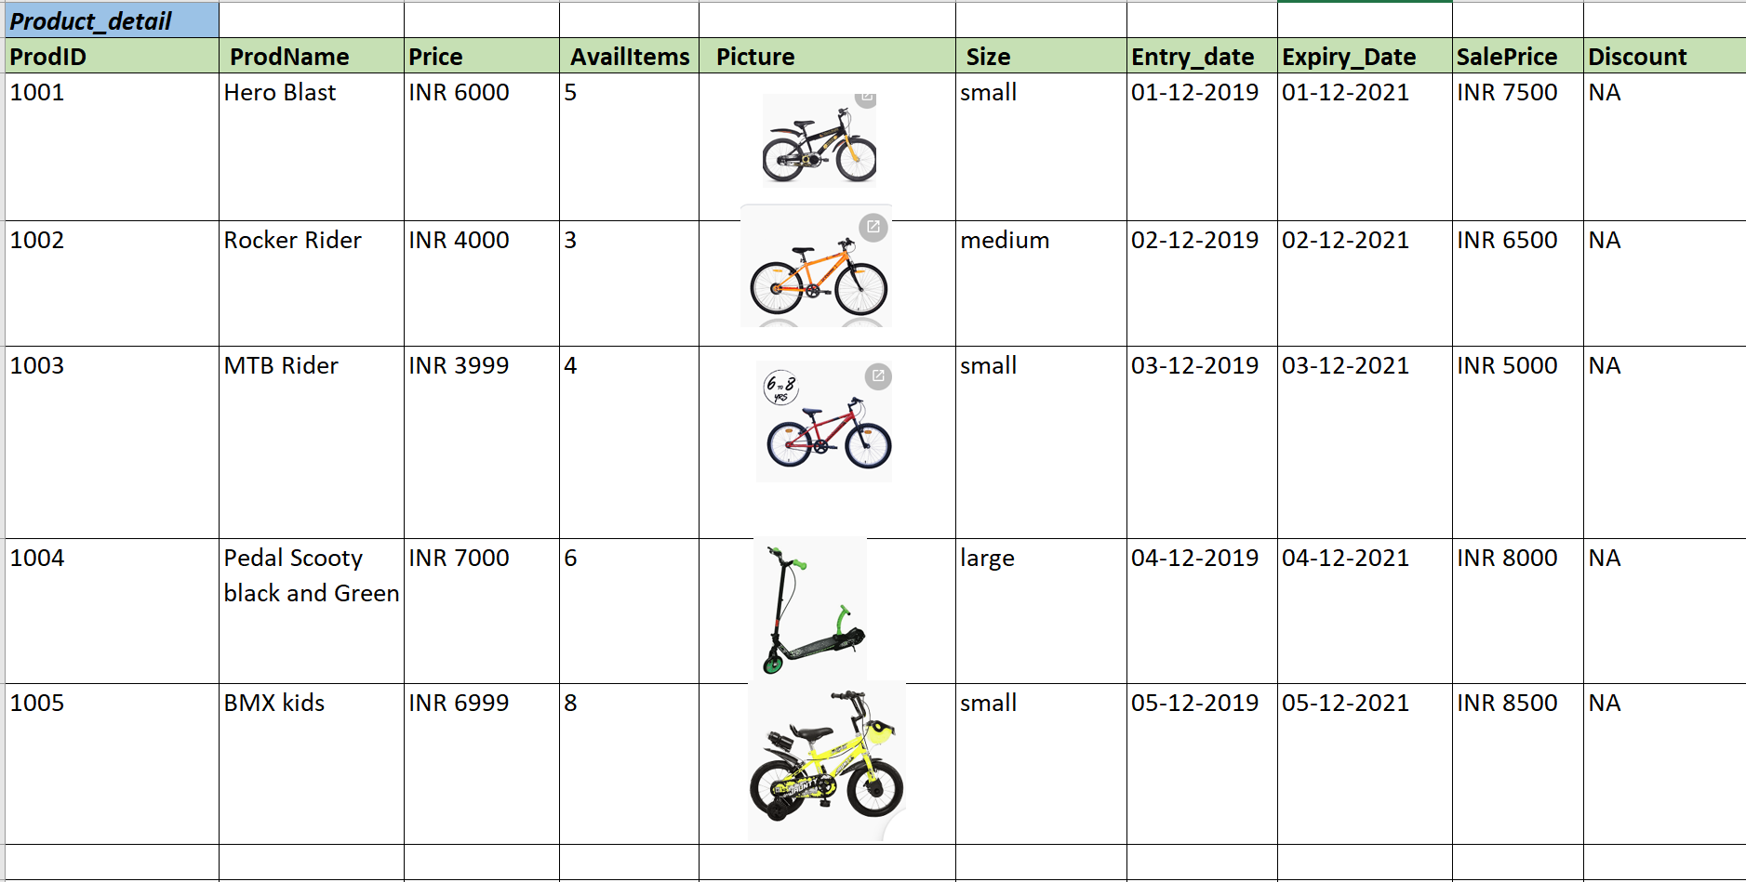

**Customer Detail Table**

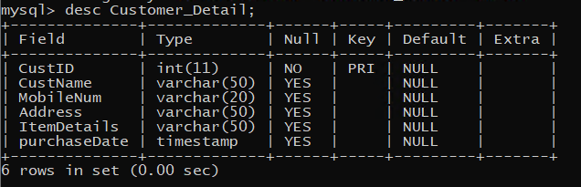

**Sample Data:-**

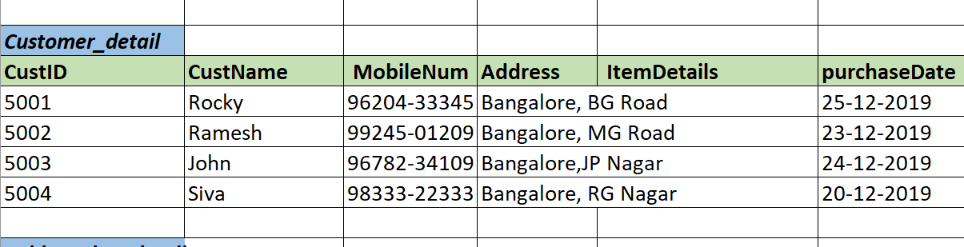

**Sold_Product_Detail**

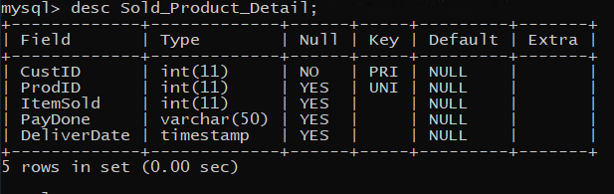

**Sample Data:-**

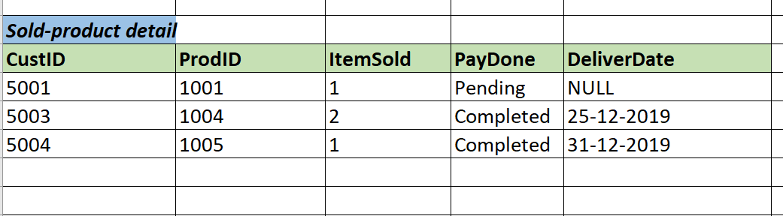

**Flow Diagram:-**

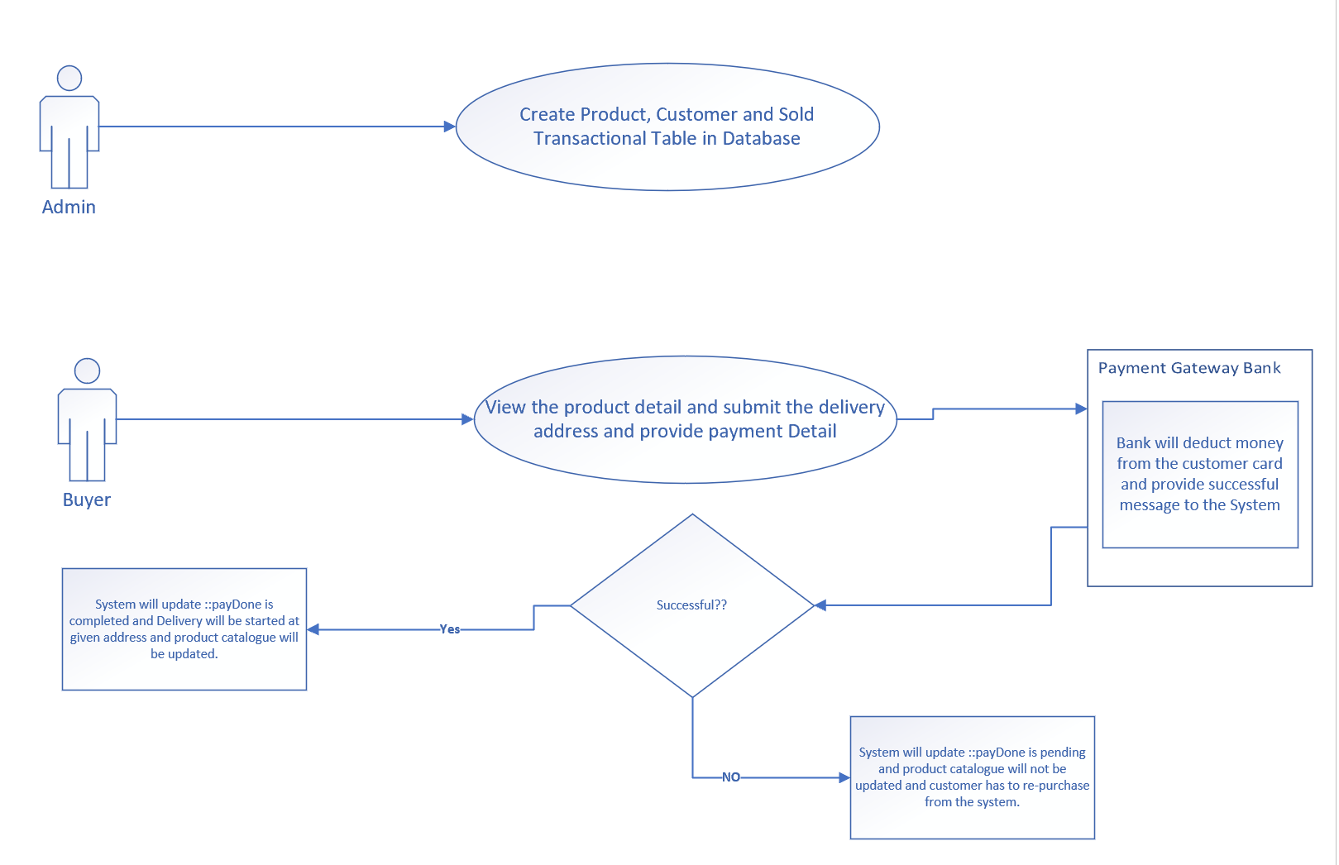

**Assumptions:-**

This project has a scope to use only database transaction using python and mySQL database. The concept of master database , transaction database and payment system are the core features of e-commerce but we have not implement payment system and user interface using web. This is considered as out of scope and however we considered as part of design as extensible of the project. The concept is implemented at the SQL statement level only. Discount and picture can be NULL however picture is considered as BLOB.

**Advantage: -**

#1. Date/format used STR_TO_DATE('01-12-2019','%d-%m-%Y') to avoid format error.

#2. convertToBinaryData method used to insert image file as BLOB type in the Product table.

#3. write_file method used to read blob from the Product table.

#4. Implemented exception handling using try/except/finally.

#5. Implemented Update BLOB method.

def UpdateBLOB(productID, imagefilename):

print("Update BLOB into Product_Detail Table")

try:

connection = mysql.connector.connect(host='localhost’ database='dbecommerce' user=‘DbeCommerece’,password='123@Password')

cursor = connection.cursor()

sql_update_blob_query = """ Update Product_Detail Set Picture = %s where ProdId = %s"""

ebinfile = convertToBinaryData(imagefilename)

# Convert data into tuple format

update_blob_tuple = (ebinfile, productID)

result = cursor.execute(sql_update_blob_query, update_blob_tuple)

connection.commit()

print("Image updated successfully as a BLOB into product_detail table", result)

except mysql.connector.Error as error:

print("Failed inserting BLOB data into MySQL table {}".format(error))

finally:

if (connection.is_connected()):

cursor.close()

connection.close()

print("MySQL connection is closed")

**Used method: -**

|  |  |
| --- | --- |
| **Function Name** | **Function Logic** |
| create() | database create main method |
| db_create() | Schema create method called in Create method |
| tab_create() | Table create method called in Create method |
| searchProductDetail() | Search required product information method. |
| insertProductDetail() | Insert method for Product related information. |
| insertCustomerDetail() | Insert method for Customer related information. |
| insertSold_Product_Detail() | Insert method for sold product items. |
| dispProductDetail() | Display Product information |
| dispCustomerDetail() | Display Customer information |
| dispSold_Product_Detail() | Display Sold Product information |
| updateProductDetail() | Update product information in the table for given id. |
| deleteProductDetail() | Delete product information from the table for given id. |
| deleteCustomerDetail() | Delete customer information from the table for given id. |
| deleteSoldProductDetail() | Delete sold product information from the table for given id. |
| deleteSoldCustomerDetail() | Delete sold product to customer information from the table for given id. |
| convertToBinaryData(filename) | Convert picture file into BLOB and save into the database product detail table |
| write_file(data, filename) | Retrieve BLOB from the table and save into picture file in the local drive. |

# CODING

# *import mysql.connector*

# *from mysql.connector import Error*

# 

# 

# *# Database create*

# *def db_create():*

# *conn=mysql.connector.connect(host='localhost',user=‘DbeCommerece’,password='123@Password')*

# *a=conn.cursor()*

# *db_name=input('Enter db name:')*

# *a.execute('create database '+db_name)*

# *print('Database has been created successfully')*

# *return db_name*

# *conn.commit()*

# *# Table create*

# *def tab_create():*

# *conn=mysql.connector.connect(host='localhost',database='dbecommerce',user=‘DbeCommerece’,password='123@Password')*

# *a=conn.cursor()*

# *tab_name=input('Enter table name: (either Product_DetailTest, or Customer_Detail or Sold_Product_Detail)')*

# 

# *if (tab_name == "Product_DetailTest"):*

# 

# *a.execute('create table '+tab_name+' (ProdID int primary key, ProdName varchar(50), Price Decimal(7,2), AvailItems int, Picture blob, Size varchar(50), Entry_date timestamp, Expiry_Date timestamp, SalePrice decimal(7,2), Discount varchar(50));')*

# *#create table Product_Detail(ProdID int primary key, ProdName varchar(50), Price Decimal(7,2), AvailItems int, Picture blob, Size varchar(50), Entry_date timestamp, Expiry_Date timestamp, SalePrice decimal(7,2), Discount varchar(50));*

# *print('Table has been created successfully')*

# *conn.commit()*

# 

# *elif (tab_name == "Customer_Detail"):*

# *a.execute('create table '+tab_name+'(CustID int primary key, CustName varchar(50), MobileNum varchar(20), Address varchar(50), ItemDetails varchar(50), purchaseDate timestamp);')*

# *#create table Customer_Detail (CustID int primary key, CustName varchar(50), MobileNum varchar(20), Address varchar(50), ItemDetails varchar(50), purchaseDate timestamp);*

# *print('Table has been created successfully')*

# *conn.commit()*

# *elif (tab_name == "Sold_Product_Detail"):*

# *a.execute('create table '+tab_name+' (CustID int primary key, foreign key (CustID) References Customer-Detail(CustID) , ProdID int unique key, foreign key (ProdID) References Product-Detail(ProdID) ,ItemSold int, PayDone varchar(50), DeliverDate timestamp)')*

# *# create table Sold_Product_Detail (CustID int primary key, foreign key (CustID) References Customer_Detail(CustID) , ProdID int unique key, foreign key (ProdID) References Product_Detail(ProdID) ,ItemSold int, PayDone varchar(50), DeliverDate timestamp)*

# *print('Table has been created successfully')*

# *conn.commit()*

# *else:*

# *print('invalid table name')*

# 

# *# Database and Table create function based on choice*

# *def create():*

# 

# *print("a.DataBase Creation")*

# *print("b.Table Creation")*

# *ch1=input('Enter choice (either a or b):')*

# 

# *if(ch1=='a'):*

# *db_create()*

# *elif(ch1=='b'):*

# *tab_create()*

# *else:*

# *print("Invalid choice::")*

# *#Search Product with product Name*

# *def searchProductDetail():*

# *# Search only for Product information and Sale price. All other fields are hidden and its for extension of application.*

# 

# *conn=mysql.connector.connect(host='localhost',database='dbecommerce',user=‘DbeCommerece’,password='123@Password')*

# *a=conn.cursor()*

# *r=input('Enter product name:')*

# *a.execute("select ProdID,ProdName,Price,Size, Entry_date, Expiry_Date, SalePrice, AvailItems,Discount from Product_Detail where prodName='"+ str(r) + "'")*

# *data=a.fetchall()*

# 

# *if(data):*

# *print('Existing details are::')*

# *for row in data:*

# *print("Product Id = ", row[0], )*

# *print("Product Name = ", row[1])*

# *print("Available Price = ", row[2])*

# *print("Size = ", row[3])*

# *print("Stock Entry Date = ", row[4])*

# *print("Stocke Expiry Date = ", row[5])*

# *print('SalePrice=',row [6])*

# *print('AvailItems=',row[7])*

# *print('Discount=',row[8])*

# 

# 

# *else:*

# *print('details not found:::!')*

# *conn.commit()*

# *def convertToBinaryData(filename):*

# *# Convert digital data to binary format*

# *with open(filename, 'rb') as file:*

# *binaryData = file.read()*

# *return binaryData*

# *def write_file(data, filename):*

# *# Convert binary data to proper format and write it on Hard Disk*

# *with open(filename, 'wb') as file:*

# *file.write(data)*

# 

# *def insertProductDetail():*

# *#Insert Prodcut Data*

# 

# *c=1*

# *no=int(input('Enter how many::'))*

# *while(c<=no):*

# *conn=mysql.connector.connect(host='localhost',database='dbecommerce',user=‘DbeCommerece’,password='123@Password')*

# *a=conn.cursor()*

# *r=int(input('Enter product ID:'))*

# *n=input('Enter Product name:')*

# *m=input('Enter Available Price:')*

# *d=input('Enter AvailItems:')*

# 

# 

# *f = input('Enter Size:')*

# 

# *g = input('Enter Entry Date in this format (dd-mm-yyyy)')*

# 

# 

# *h = input('Enter Expiry Date in this format (dd-mm-yyyy:')*

# 

# *I = input('Enter Sale Price:')*

# 

# *J = input('Enter Discount: enter(NA) :: ')*

# *e = input('Enter bicycle picture path:')*

# *#binary to str need to fix*

# *# ebinfile = convertToBinaryData(str(e))*

# *ebinfileNull = "NULL"*

# 

# *query='insert into Product_Detail values ("'+str(r)+'","'+n+'",'+m+',"'+d+ '","'+ ebinfileNull + '","'+f+ '", STR_TO_DATE("'+ str(g) + '","%d-%m-%Y") ,STR_TO_DATE("' + str(h) + '","%d-%m-%Y"),"'+I+ '","'+J+ '")'*

# *#insert into Product_Details values ('1001',"Hero Blast",'6000',"5", ‘picutre path’, ‘small’, ’01-12-2019’, ’01-12-2019’, 7500, ‘NA’ )*

# *a.execute(query)*

# *print('successfully inserted')*

# *conn.commit()*

# *#Update BLOB*

# *UpdateBLOB(str(r), str(e))*

# *#next loop*

# *c+=1*

# 

# 

# *def UpdateBLOB(productID, imagefilename):*

# *print("Update BLOB into Product_Detail Table")*

# *try:*

# *connection = mysql.connector.connect(host='localhost',*

# *database='dbecommerce',*

# *user=‘DbeCommerece’,*

# *password='123@Password')*

# *cursor = connection.cursor()*

# *sql_update_blob_query = """ Update Product_Detail Set Picture = %s where ProdId = %s"""*

# 

# *ebinfile = convertToBinaryData(imagefilename)*

# 

# *# Convert data into tuple format*

# *update_blob_tuple = (ebinfile, productID)*

# *result = cursor.execute(sql_update_blob_query, update_blob_tuple)*

# *print (result)*

# *connection.commit()*

# *print("Image updated successfully as a BLOB into product_detail table", result)*

# *except mysql.connector.Error as error:*

# *print("Failed inserting BLOB data into MySQL table {}".format(error))*

# *finally:*

# *if (connection.is_connected()):*

# *cursor.close()*

# *connection.close()*

# *print("MySQL connection is closed")*

# 

# 

# *# Insert Customer Data*

# *def insertCustomerDetail():*

# 

# *c=1*

# *no=int(input('Enter how many::'))*

# *while(c<=no):*

# *conn=mysql.connector.connect(host='localhost',database='dbecommerce',user=‘DbeCommerece’,password='123@Password')*

# *a=conn.cursor()*

# *r=int(input('Enter Customer ID:'))*

# *n=input('Enter Customer name:')*

# *m=input('Enter Mobile Number:')*

# *d=input('Enter Address:')*

# *e = input('Enter Item Details:')*

# *g = input('Enter purchase Date in this format (dd-mm-yyyy)')*

# *query='insert into Customer_Detail values ("'+str(r)+'","'+n+'","'+m+'","'+d+ '","'+ e + '", STR_TO_DATE("' + g + '","%d-%m-%Y"))'*

# *#insert into Customer_Details values (5001,"Rocky ",’96206-33345,’Bangalore BG Road’, ‘Hero Blast Cycle’, ’25-12-2019’)*

# *a.execute(query)*

# *print('successfully inserted')*

# *conn.commit()*

# *c+=1*

# 

# *def insertSold_Product_Detail():*

# 

# *c=1*

# *no=int(input('Enter how many::'))*

# *while(c<=no):*

# *conn=mysql.connector.connect(host='localhost',database='dbecommerce',user=‘DbeCommerece’,password='123@Password')*

# *a=conn.cursor()*

# *r=int(input('Enter Customer ID:'))*

# *p=int(input('Enter product ID:'))*

# *n=input('Enter number of item sold:')*

# *m=input('Enter Pay Status: e.g (Completed or Pending or Cancelled) :')*

# *g = input('Enter Delivered Date in this format (dd-mm-yyyy) :')*

# 

# 

# *query='insert into Sold_Product_Detail values ("'+str(r)+'","'+str(p)+'","'+n+'","'+m +'", STR_TO_DATE("' + g + '","%d-%m-%Y"))'*

# *#insert into Sold_Product_Detail values (5001,1001 ,1,"pending",’25-12-2019’)*

# *a.execute(query)*

# *print('success Inserted ')*

# *conn.commit()*

# *c+=1*

# 

# *def dispProductDetail():*

# *conn=mysql.connector.connect(host='localhost',database='dbecommerce',user=‘DbeCommerece’,password='123@Password')*

# *a=conn.cursor()*

# *a.execute("select ProdID,ProdName,Price,Size, Entry_date, Expiry_Date, SalePrice, AvailItems,Discount from Product_Detail")*

# *data=a.fetchall()*

# *if(data):*

# *print('Existing details are::')*

# *for row in data:*

# *print("Product Id = ", row[0], )*

# *print("Product Name = ", row[1])*

# *print("Available Price = ", row[2])*

# *print("Size = ", row[3])*

# *print("Stock Entry Date = ", row[4])*

# *print("Stocke Expiry Date = ", row[5])*

# *print('SalePrice=',row [6])*

# *print('AvailItems=',row[7])*

# *print('Discount=',row[8])*

# 

# *else:*

# *print('Zero record found:::!')*

# 

# *conn.commit()*

# *def dispCustomerDetail():*

# *conn=mysql.connector.connect(host='localhost',database='dbecommerce',user=‘DbeCommerece’,password='123@Password')*

# *a=conn.cursor()*

# *a.execute("select * from Customer_Detail")*

# *data=a.fetchall()*

# *if(data):*

# *print('Existing details are::')*

# *for row in data:*

# *print("Customer Id = ", row[0], )*

# *print("Customer Name = ", row[1])*

# *print('Mobile Number=',row [2])*

# *print('Address=',row[3])*

# *print('ItemDetails=',row[4])*

# *print('Purchase Date=',row[5])*

# 

# *else:*

# *print('Zero record found:::!')*

# *conn.commit()*

# 

# 

# *def dispSold_Product_Detail():*

# *conn=mysql.connector.connect(host='localhost',database='dbecommerce',user=‘DbeCommerece’,password='123@Password')*

# *a=conn.cursor()*

# *a.execute("select * from Sold_Product_Detail")*

# *data=a.fetchall()*

# *if(data):*

# *print('Existing details are::')*

# *for row in data:*

# *print("Customer Id = ", row[0], )*

# *print("Product Id = ", row[1])*

# *print('No. of Item Sold=',row [2])*

# *print('Payment Status=',row[3])*

# *print('Deliver Date=',row[4])*

# 

# 

# *else:*

# *print('Zero record found:::!')*

# 

# *conn.commit()*

# *def updateProductDetail():*

# *# Update only for Product some fields such as product name, price, soldPrice and availItems*

# *conn=mysql.connector.connect(host='localhost',database='dbecommerce',user=‘DbeCommerece’,password='123@Password')*

# *a=conn.cursor()*

# *r=int(input('Enter product id to update details: '))*

# *query='Select * from Product_Detail where prodID='+ str(r)*

# *a.execute(query)*

# *data=a.fetchall()*

# *if(data):*

# *print('Existing details are::')*

# *for row in data:*

# *print("Product Id = ", row[0], )*

# *print("Product Name = ", row[1])*

# *print('SalePrice=',row [8])*

# *print('AvailItems=',row[3])*

# 

# *print('\nEnter the new details:::')*

# 

# *n=input('Enter New Product name:')*

# *m=input('Enter new available price:')*

# *d=input('Enter new AvailItems:')*

# *f = input('Enter new Sale Price:')*

# *query='update Product_Detail set Prodname="'+n+'",price='+m+',AvailItems ='+d +',SalePrice ='+f +' where ProdID='+str(r)*

# *#update Product Details set Prodname="abc",price=4000.00,AvailItems="30" , SoldPrice = 7600 where prodid=1001*

# *a.execute(query)*

# *print('updated successfully::!!')*

# *conn.commit()*

# *else:*

# *print('ProdID ',r,' doesnt exists')*

# *conn.commit()*

# *def deleteProductDetail():*

# *conn=mysql.connector.connect(host='localhost',database='dbecommerce',user=‘DbeCommerece’,password='123@Password')*

# *a=conn.cursor()*

# 

# *r=int(input('Enter Product ID of Product-Details to details: '))*

# *a.execute('select * from Product_Detail where prodID='+ str(r))*

# 

# *data=a.fetchall()*

# *if(data):*

# 

# *ch=int(input('Are you sure to delete entire table content ...press 1 if yes...press any key if no'))*

# 

# 

# *if(ch==1):*

# *# first delete from the referenced table to avoid confusion.*

# *deleteSoldProductDetail()*

# *query='delete from Product_Detail where prodID='+str(r)*

# *a.execute(query)*

# *print('ProdID ',r,' details has been deleted successfully:::')*

# *conn.commit()*

# *else:*

# *print('ProdID',r,'details not deleted based on your confirmation::')*

# *else:*

# *print('ProdID ',r,' doesnot exists::')*

# *print("\n"*20)*

# *def deleteCustomerDetail():*

# *conn=mysql.connector.connect(host='localhost',database='dbecommerce',user=‘DbeCommerece’,password='123@Password')*

# *a=conn.cursor()*

# 

# *r=int(input('Enter Customer ID of Customer_Details to details:'))*

# *a.execute('select * from Customer_Detail where CustID='+str(r))*

# *data=a.fetchall()*

# 

# *if(data):*

# *ch=int(input('Are you sure to delete entire table content ...press 1 if yes...press any key if no'))*

# *if(ch==1):*

# *# first delete from the referenced table to avoid confusion.*

# *deleteSoldCustomerDetail()*

# *query='delete from Customer_Detail where CustID='+str(r)*

# *a.execute(query)*

# *print('CustID ',r,' details has been deleted successfully:::')*

# *conn.commit()*

# *else:*

# *print('CustID',r,'details not deleted based on your confirmation::')*

# *else:*

# *print('CustID ',r,' doesnot exists::')*

# *print("\n"*20)*

# *def deleteSoldProductDetail():*

# *# makesure either product id or customer id deleted before deleting customer or product data.*

# *conn=mysql.connector.connect(host='localhost',database='dbecommerce',user=‘DbeCommerece’,password='123@Password')*

# *a=conn.cursor()*

# *r=int(input('Enter Product ID of Sold_Product_Details to details'))*

# 

# *a.execute('select * from Sold_Product_Detail where prodID='+str(r))*

# *data=a.fetchall()*

# *if(data):*

# *ch=int(input('Are you sure to delete entire table content ...press 1 if yes...press any key if no'))*

# *if(ch==1):*

# *query='delete from Sold_Product_Detail where prodID='+str(r)*

# *a.execute(query)*

# *print('ProdID ',r,' details has been deleted successfully:::')*

# *conn.commit()*

# *else:*

# *print('ProdID',r,'details not deleted based on your confirmation::')*

# *else:*

# *print('ProdID ',r,' doesnot exists::')*

# *print("\n"*20)*

# 

# 

# 

# 

# 

# 

# *def deleteSoldCustomerDetail():*

# *# makesure customer id deleted from this table to follow the normalization process.*

# *conn=mysql.connector.connect(host='localhost',database='dbecommerce',user=‘DbeCommerece’,password='123@Password')*

# *a=conn.cursor()*

# *r=int(input('Enter Customer ID of Sold_Product_Details to details: '))*

# 

# *a.execute('select * from Sold_Product_Detail where CustID='+str(r))*

# *data=a.fetchall()*

# 

# *if(data):*

# *ch=int(input('Are you sure to delete entire table content ...press 1 if yes...press any key if no'))*

# 

# *if(ch==1):*

# *query='delete from Sold_Product_Detail where custID='+str(r)*

# *a.execute(query)*

# *print('CustID ',r,' details has been deleted successfully:::')*

# *conn.commit()*

# *else:*

# *print('CustID',r,'details not deleted based on your confirmation::')*

# *else:*

# *print('CustID ',r,' doesnot exists::')*

# *print("\n"*20)*

# *print("\t\t\t\t:::E-COMMERCE (ONLINE BICYCLE) MANAGEMENT SYSTEM:::\t\t\t\t\ t\t")*

# *while(1):*

# *print("\t\t\t1.Create")*

# *print("\t\t\t2.Search Product")*

# *print("\t\t\t3.Update Product")*

# *print("\t\t\t4.Delete Product")*

# *print("\t\t\t41.Delete Customer")*

# *print("\t\t\t5.Insert Product")*

# *print("\t\t\t51.Insert Customer")*

# *print("\t\t\t52.Insert Sold Product")*

# *print("\t\t\t6.Display Product")*

# *print("\t\t\t61.Display Customer")*

# *print("\t\t\t62.Display Sold Product Detail")*

# *print("\t\t\t7.Exit")*

# 

# *print("\n"*3)*

# *ch=int(input('Enter choice::: '))*

# *if(ch==1):*

# *create()*

# *elif(ch==2):*

# *searchProductDetail()*

# *elif(ch==3):*

# *updateProductDetail()*

# *elif(ch==4):*

# *deleteProductDetail()*

# *elif(ch==41):*

# *deleteCustomerDetail()*

# *elif(ch==5):*

# *insertProductDetail()*

# *elif(ch==51):*

# *insertCustomerDetail()*

# *elif(ch==52):*

# *insertSold_Product_Detail()*

# *elif(ch==6):*

# *dispProductDetail()*

# *elif(ch==61):*

# *dispCustomerDetail()*

# *elif(ch==62):*

# *dispSold_Product_Detail()*

# *else:*

# *print('\n'*20)*

# *print('\t\t\tThanks For using e-Commerce (online bicycle) Management Software')*

# *print('\t\t\t\t\t©Sri Chaitanya 2020')*

# *break*

# *print('\n'*10)*

# OUTPUT SCREEN Screen-1: WELCOME SCREEN

# 

**Screen-2: Create option**

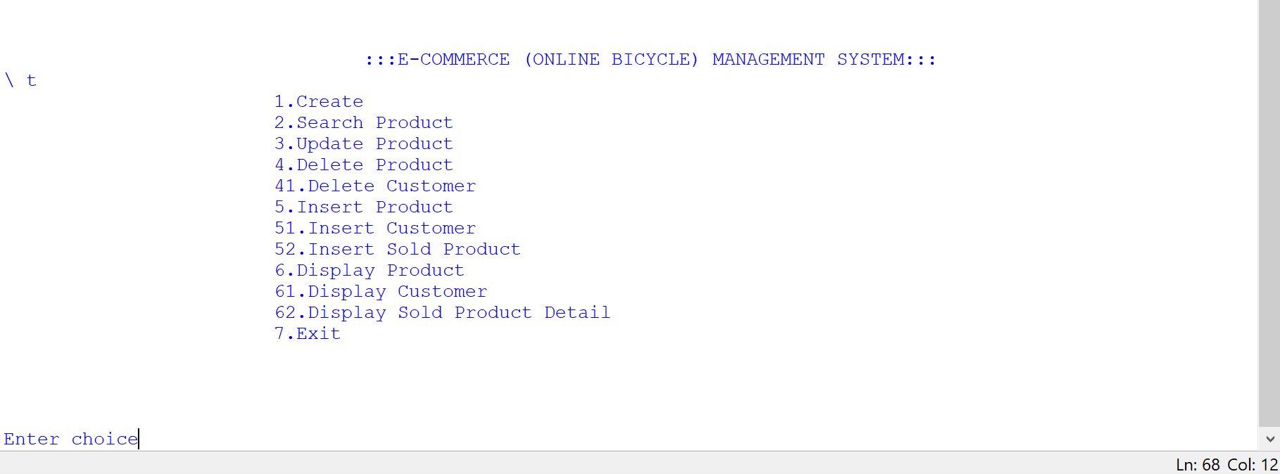

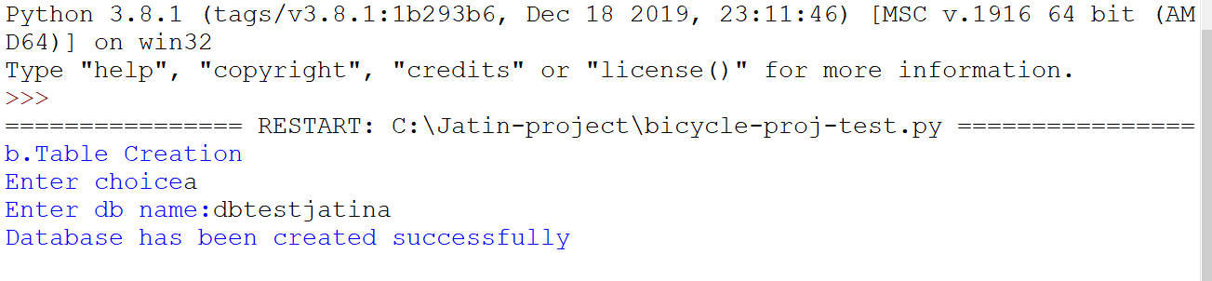

**Screen-3: Database Creation**

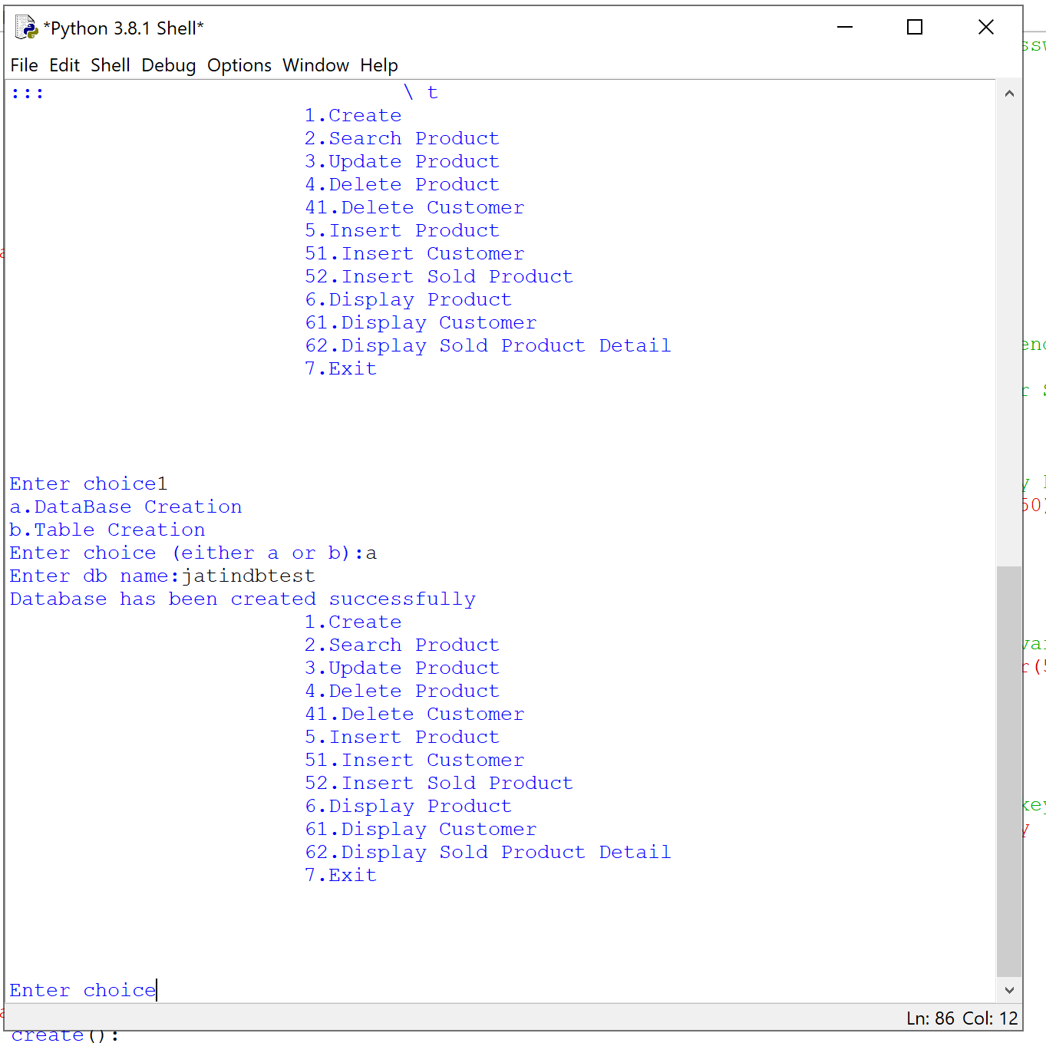

**Screen-4: Table Creation**

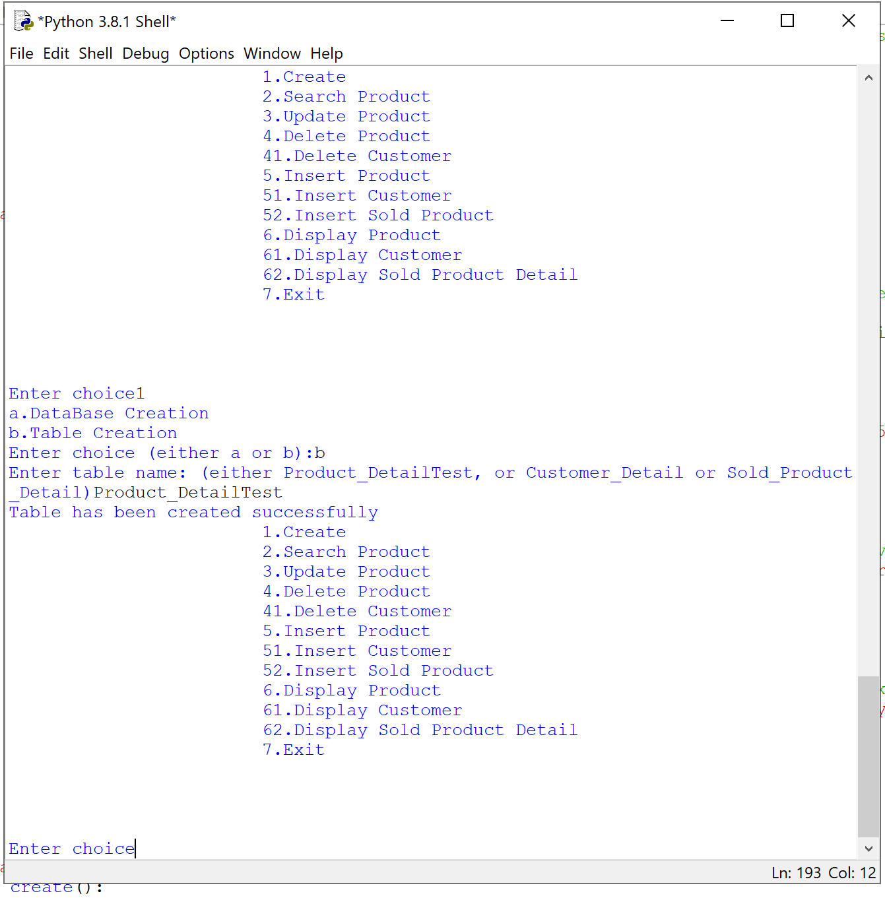

**Screen-5: Inserting data into Table**

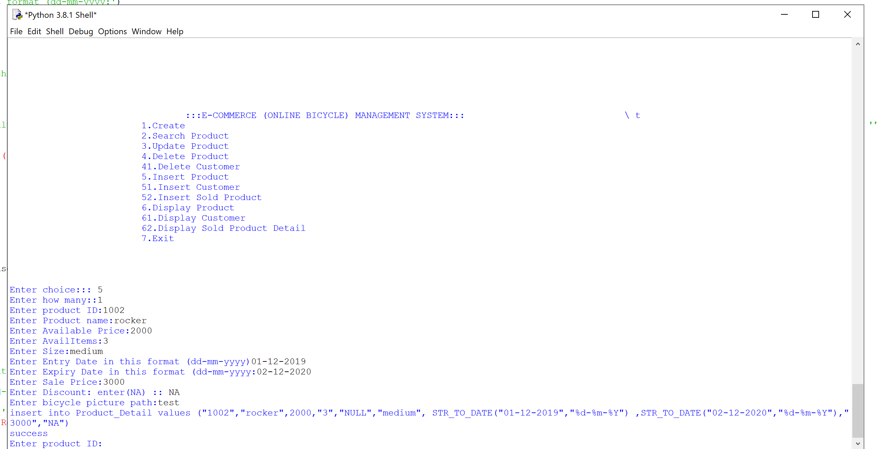

**Screen-6: Display Entire Table**

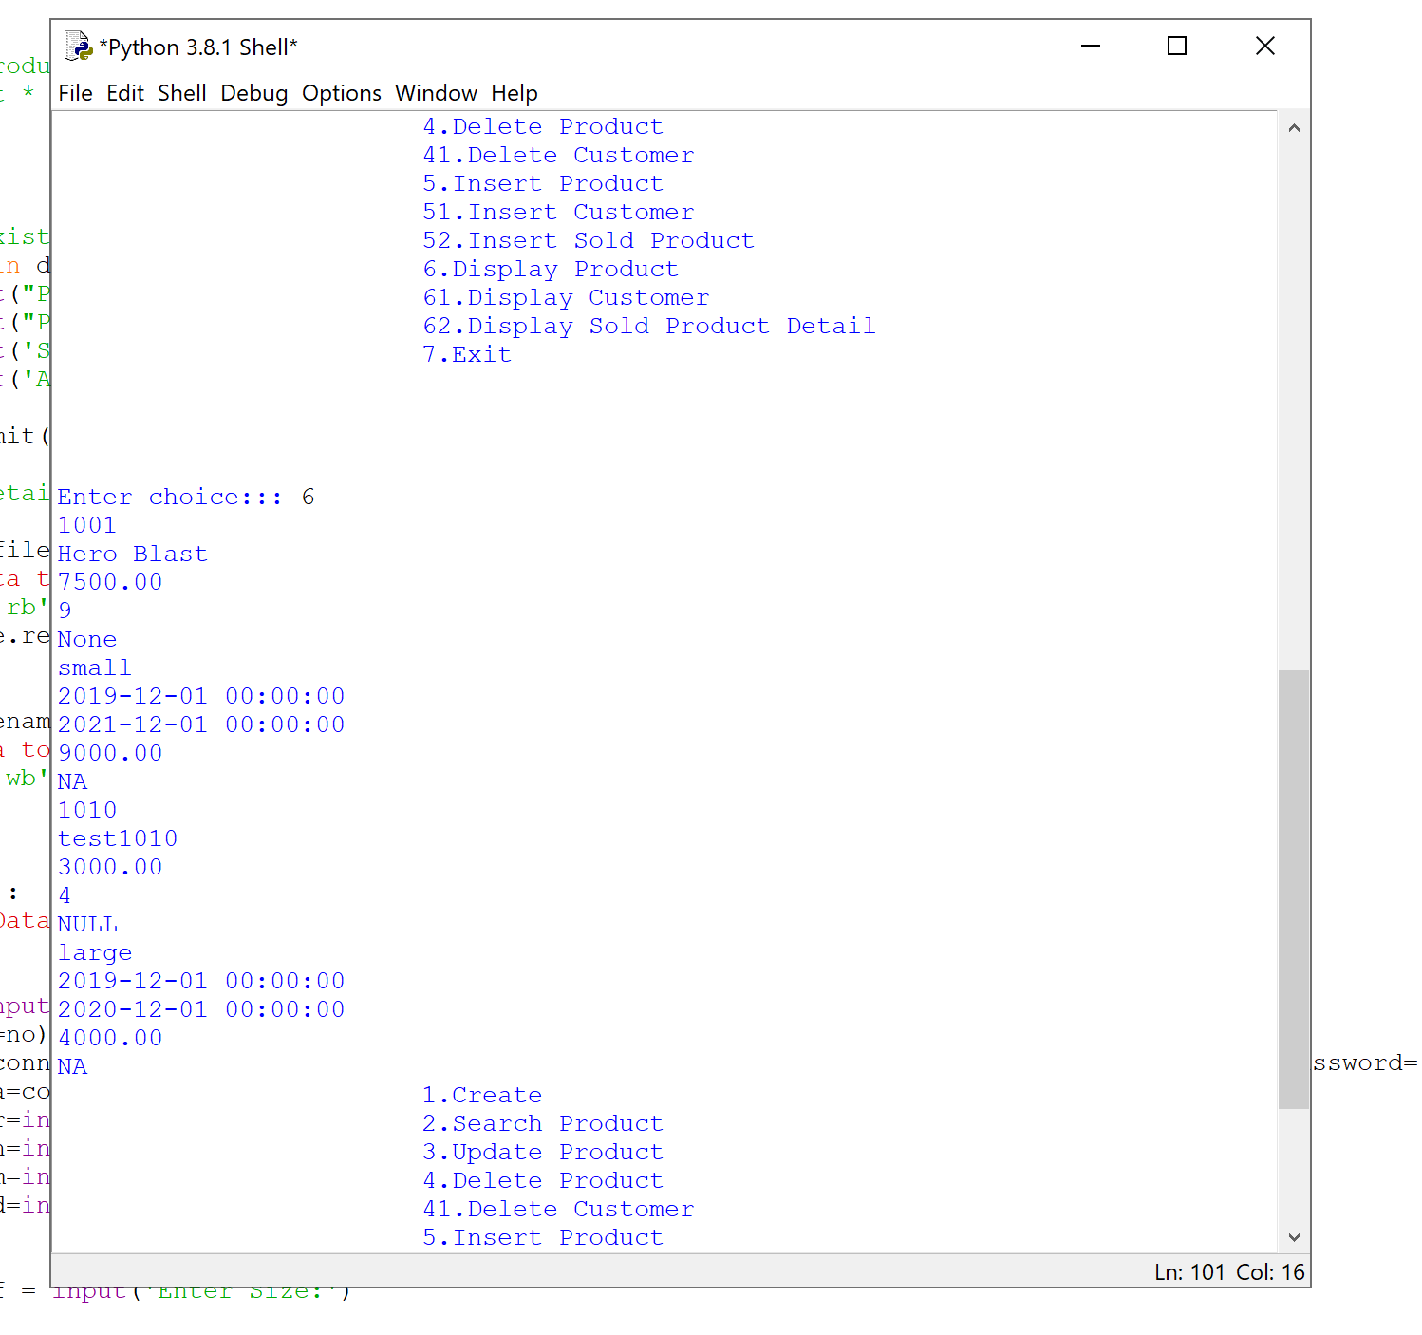

**Screen-7: Search(Successful)**

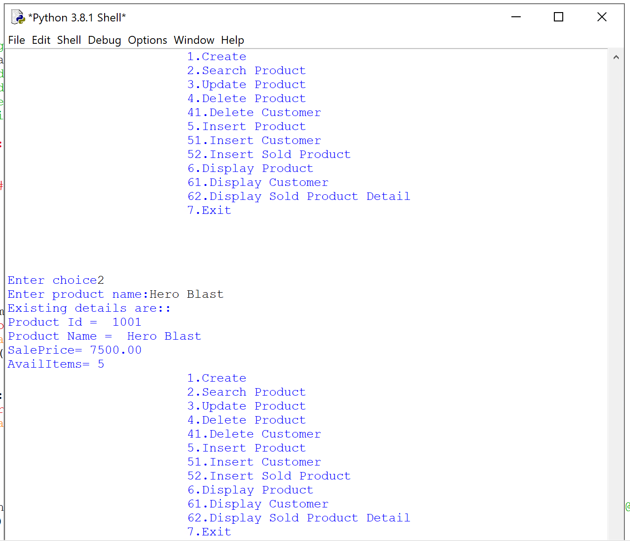

**Screen-8: Search(Un Successful)**

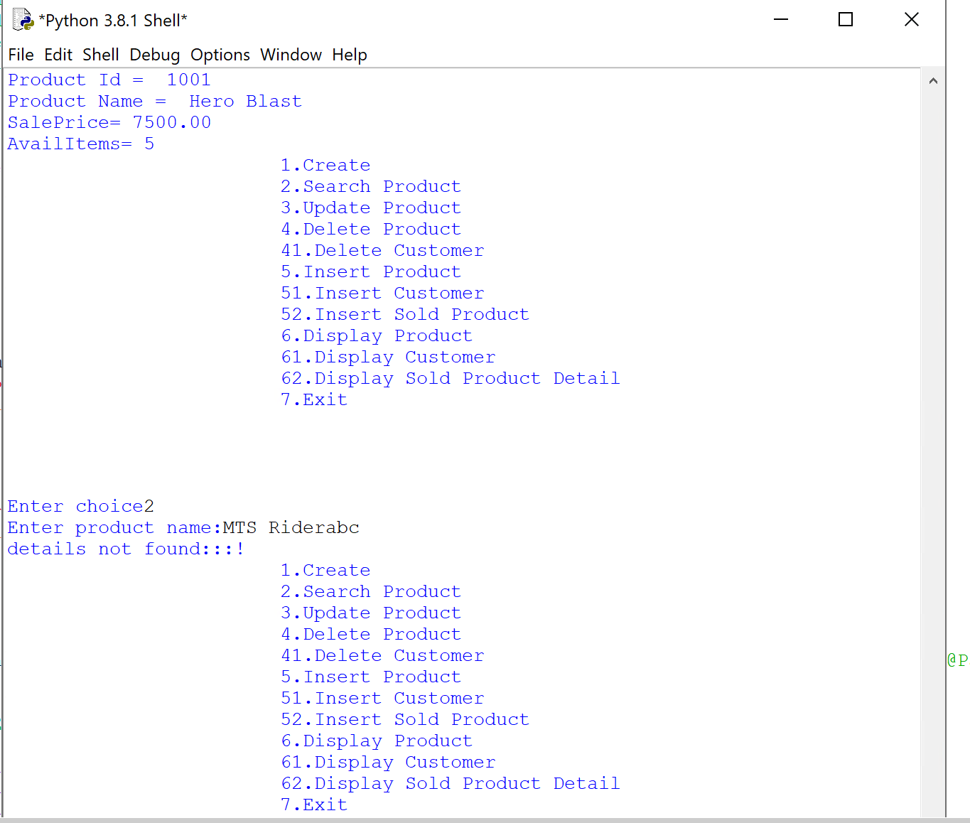

**Screen-8: Update (Successful if details Exists)**

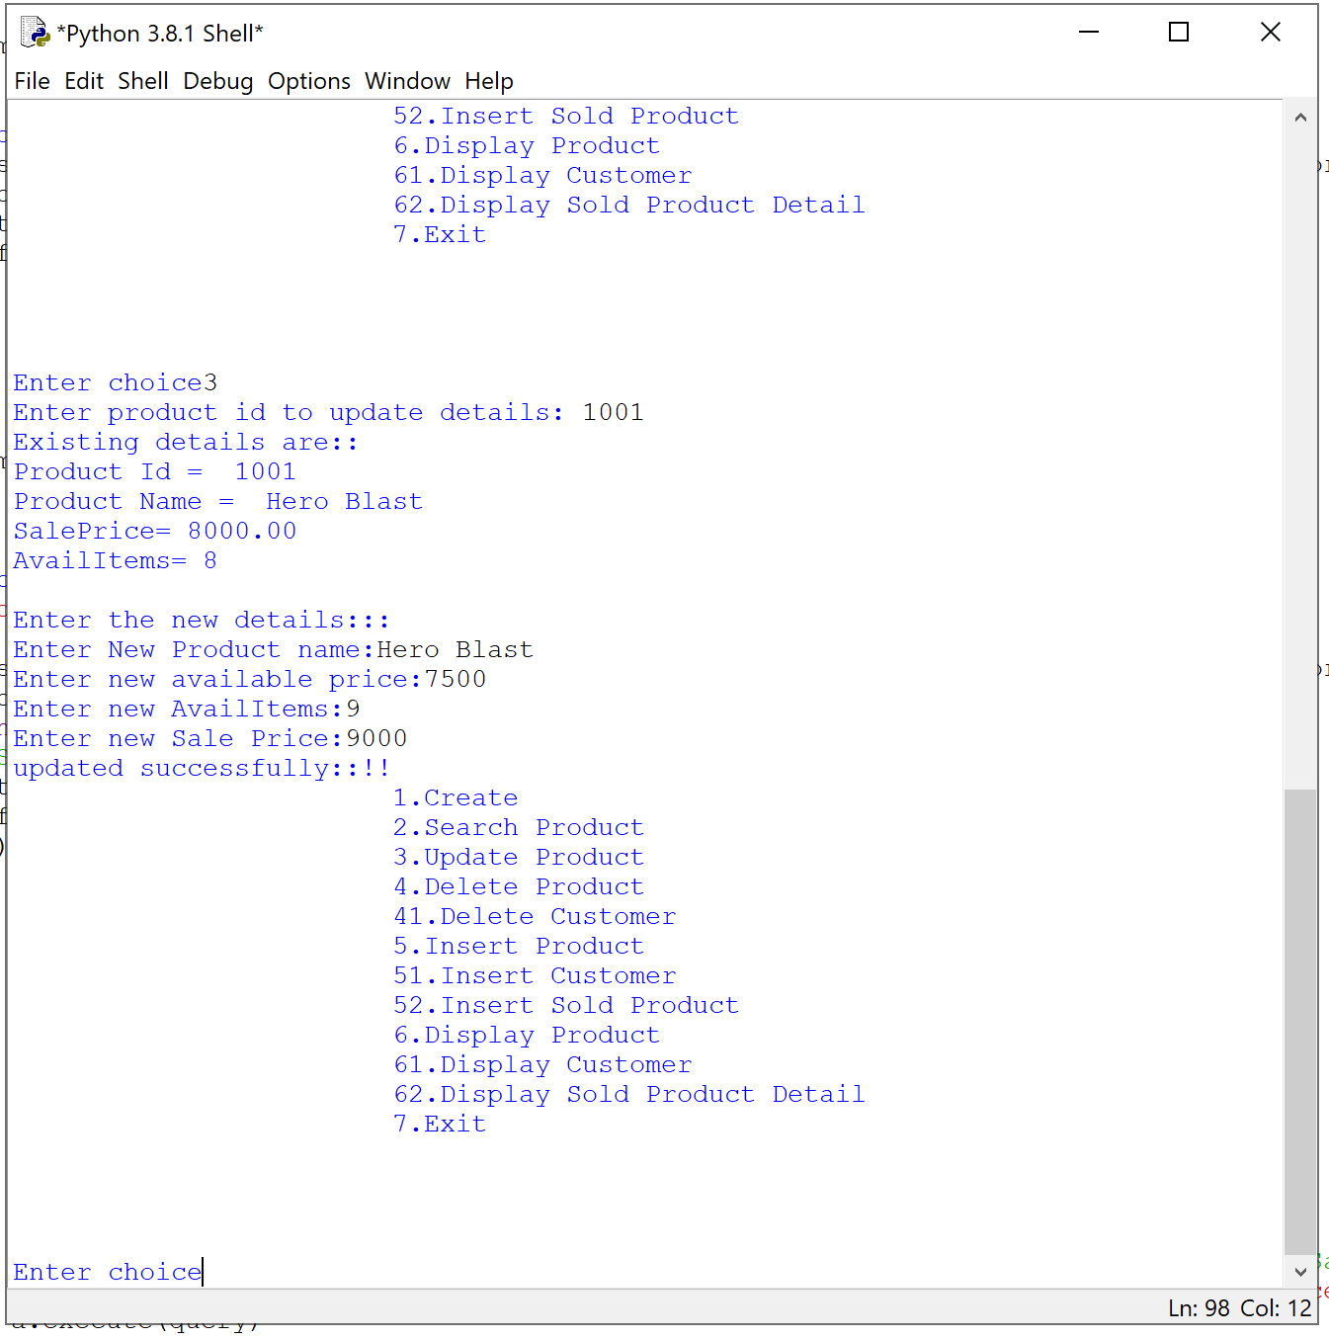

**Screen-8 (a): After Successful Update Search**

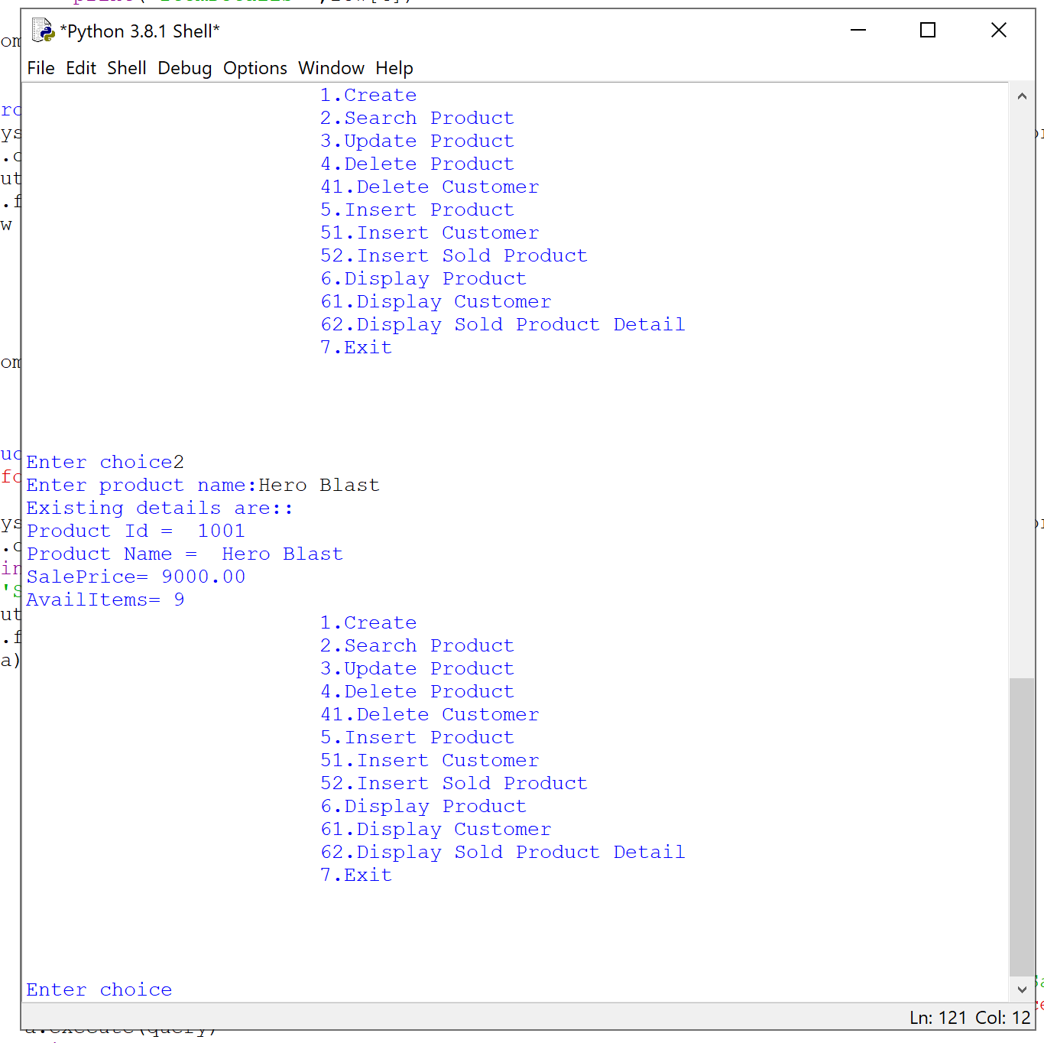

**Screen-9: Update (UnSuccessful if details doesn’t Exists)**

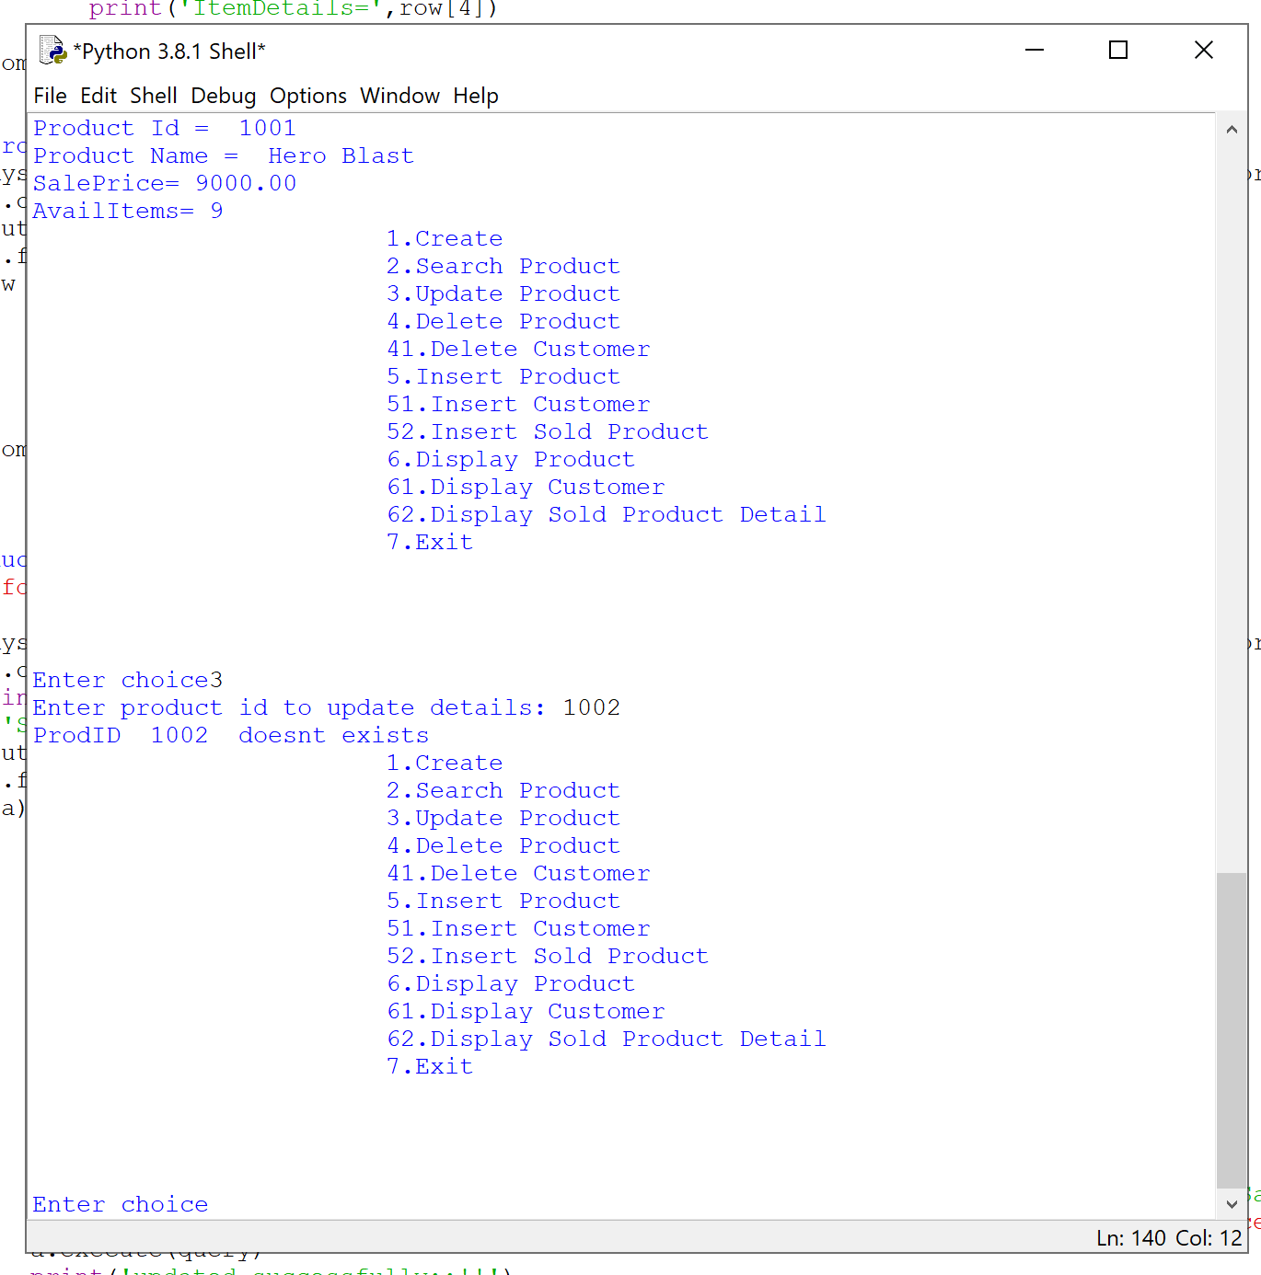

**Screen-10 (a) : Delete (Successful if details Exists)**

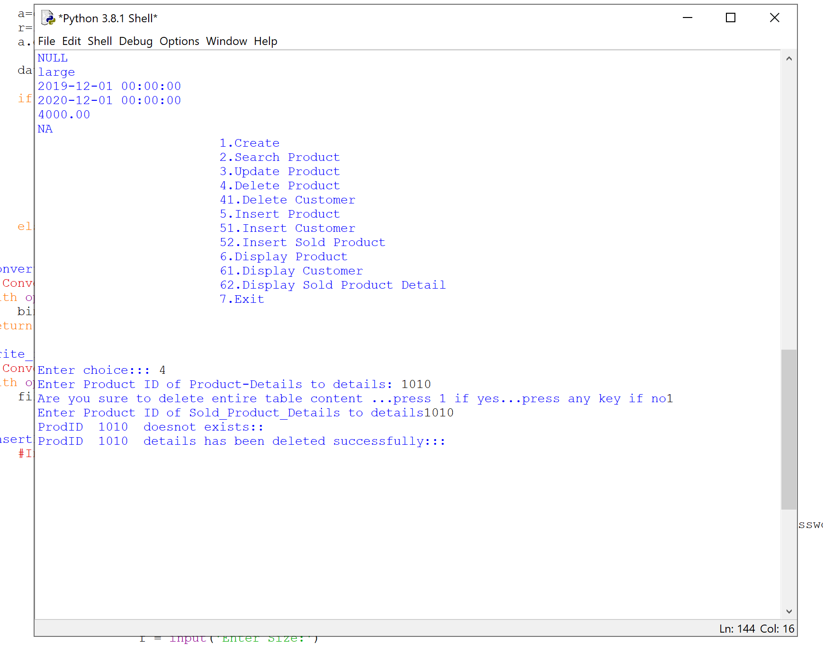

**Screen-10 (b) : Searching for deleted details**

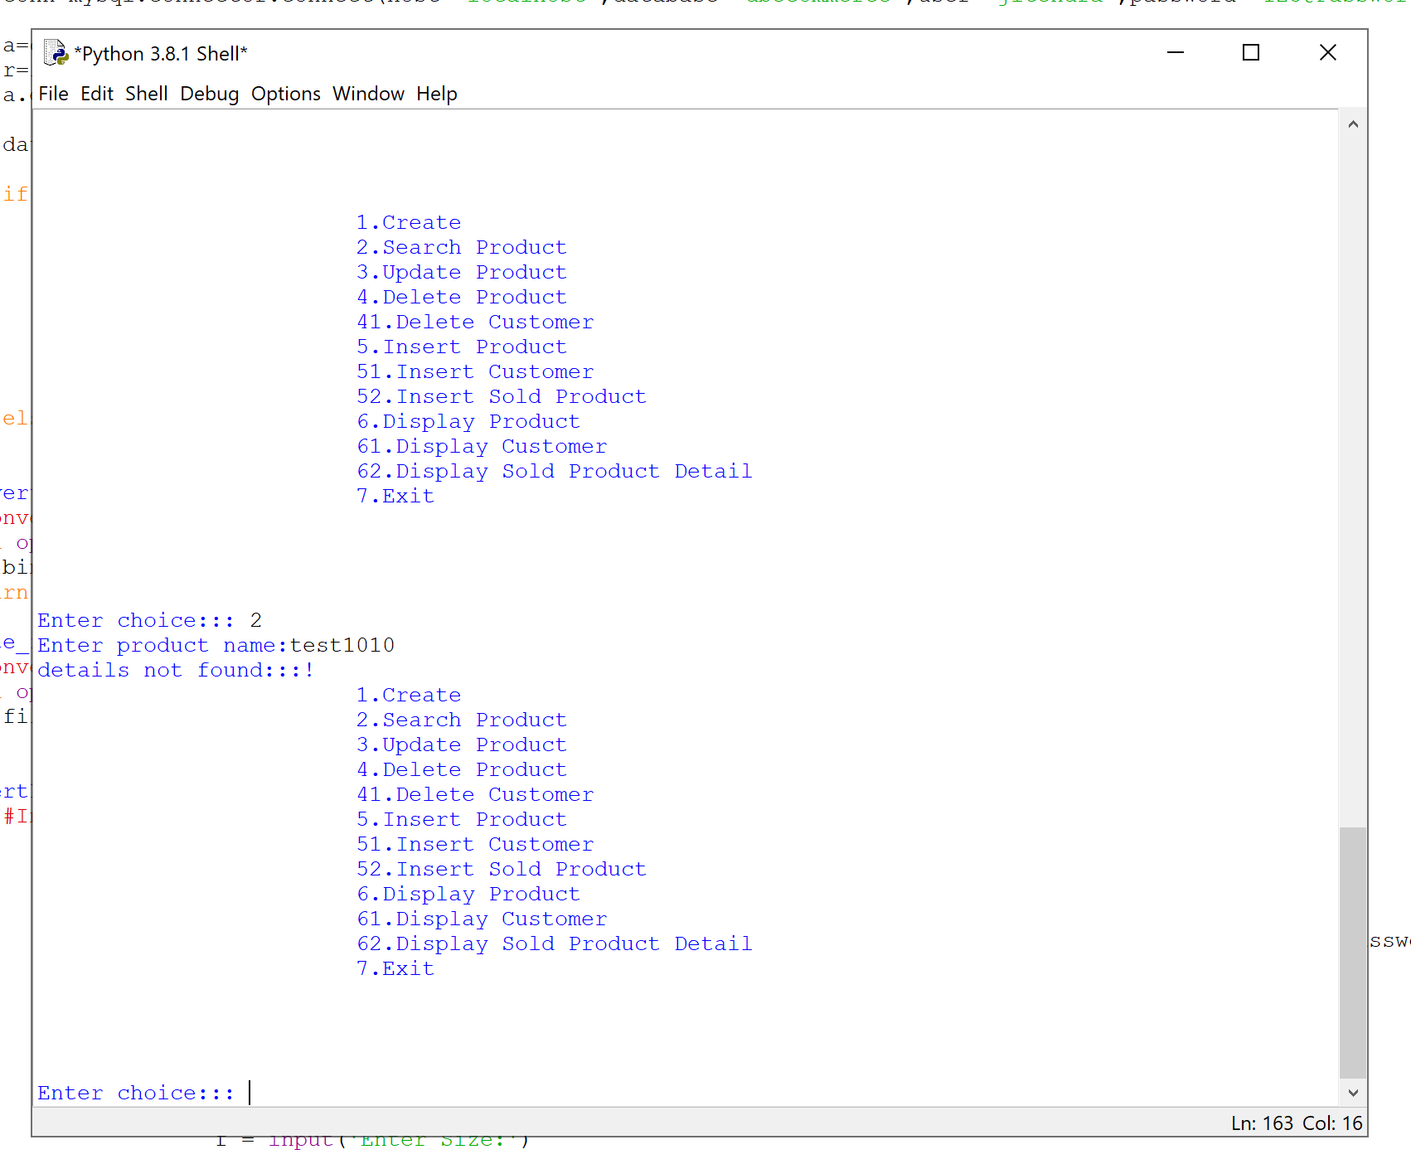

**Screen-11:Exit Screen**

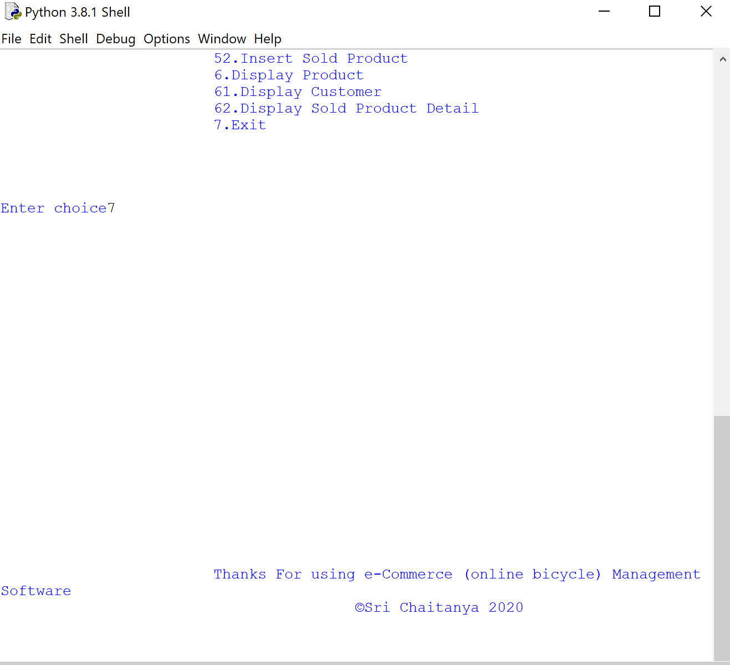

**Bibliography:**

[www.google.com](http://www.google.com/) [www.python.org](http://www.python.org/). [www.geeksforgeeks.org](http://www.geeksforgeeks.org/) [www.stackoveflow.com](http://www.stackoveflow.com/)

Martin Brown and Martin C Brown, *“Python: The Complete Reference”*,Mc-Graw-Hill,2001